Transformation of Information through Multimedia Based Interactive Media for

Desi Cotton Crop

**Submitted By:**

Solanki Hemit K.

Sem : 7th semester

Reg. No : 06-0105-2012

Roll No: 16

**Guided By:**

|  |  |  |
| --- | --- | --- |
| **Major Guide** | **External Guide** | **Minor Guide** |
| Prof.K.P.Patel | Prof.N.M.Wegad | Dr..B.A.Amin |
| **Signature:** | **Signature:** | **Signature:** |



**College of Agricultural Information Technology**

**CAIT, AAU, Anand**

**Acknowledgement**

A project is a golden opportunity for learning and self-development. I consider ourselves very lucky and honoured to have so many wonderful people lead us through in the completion of the project.

My sincere thanks to Prof. Kalpesh P.Patel, assistant Professor who in spite of being busy with his duties took time out to hear and keep us on the correct path. Your valuable guidance about the designing and motivation helps me to make this project successful. ‘Thank You’ Sir.

Dr. B.A.Amin, Assistant Professor monitored our progress and took time out from his hectic schedule. I choose this moment to acknowledge his contribution gratefully. Your special advice on advance video time ramping techniques means a lot.

I would like to thank Prof. N.M.Wegad to contribute valuable agricultural information in this information system. Moreover, I am also thankful to Prof. K.H.Patel, assistant researcher at Main Cotton Research Station, Viramgam for contributing his precious time for this project. At Last I would like to thank so many people who shared valuable information that helped me in the successful completion of the project.

**Solanki Hemit K.**

**Abstract**

Agriculture plays a vital role in India’s economy. Over 58 per cent of the rural households depend on agriculture as their principal means of livelihood. Agriculture, along with fisheries and forestry, is one of the largest contributors to the Gross Domestic Product (GDP).

Most of the emerging issues in Indian agriculture are lack of infrastructure, lack of mechanization, poor productivity, illiteracy and lack in skills required for farm management practices, sustainability and less technology has been utilized.As per census 2015, the India’s rural population is 54.06% of its whole population.As per the latest report of UNESCO 2015, there are 287 million illiterates adults in INDIA and as per census 2015, the 32% of India’s rural population is illiterate and 30% of illiteracy of whole Gujarat’s rural population causes to make unable farmer to understand the available of information. The improper information or misunderstood information may cause the bad farm practices and tends a tremendous loss. Usually, in Indian agriculture the information is broadcasted through leaflets, pamphlets, magazines or through FLDs (Front Line Demonstration). However, most of the media broadcasted doesn’t provide a region specific content to the farmer. During the FLDs, the resources have been utilized unnecessarily and time constrain makes unable an extension worker to connect with each and every farmer of state or region at particular seasonal time period.

The major emerging issues in agriculture information transfer technology can be solved by multimedia platform. The multimedia platform offers the virtualization concept that can be helpful to demonstrate the on farm practices as they were being on the actual farm. Moreover, the content can be accessed very easily and doesn’t require any special skills to get used to it. By using the multimedia technology the resources can be conserved in efficient way and the time constrain for transformation cannot be bother further. The information can be flow out in proper way and in proper format that one can easily understand. This approach can be approved as new and efficient approach for transformation of information through multimedia based interactive media.

Contents

1.0 Introduction: 8

2.0Identification of problems and possible solutions: 9

2.1 What are the actual problems? 9

2.2 Possible solutions: 9

3.0 Project requirement gathering and analysis: 11

3.1 Project requirement gathering: 11

3.2 Project requirement analysis: 12

4.0 Project perspective: 12

4.1 Preamble: 12

4.2 Objectives: 12

4.3 Scope: 13

4.4 Limitation of the proposed system: 13

4.5 About the existing system and newly proposed system: 13

4.6 Key Features: 14

4.7 Internal environment: 14

4.8 External environment: 14

5.0 Feasibility Study: 14

5.1 Technical feasibility: 15

5.1.1 Hardware interface: 15

5.2.2 Software interface: 15

5.2.3 Network interface: 15

5.2.4 Memory constrain: 15

5.2.5 Operations: 16

5.2.6 User characteristics: 16

5.2 Economics feasibility: 16

5.3 Operational or behavioural feasibility: 16

6.0 Project Planning: 17

6.1 Planning approach for multimedia project: 17

6.2Gantt Chart: 18

6.3PERT Chart: 18

7.0 Project design: 18

7.1 Structure Designing: 18

6.1.1. Navigation maps: 19

7.1.2 Architectural drawing 20

7.1.3 Hotspots: 21

7.1.4 Hyperlinks: 21

7.1.5 Icon and buttons: 21

7.2 User Interface Designing: 21

7.2.1 Graphical User Interface Designing: 22

7.2.2 Audio Interface: 22

8.0 How system works? 22

8.1 System navigation: 22

8.2 User manual: 22

9.0 Conclusion: 22

10.0 Bibliography: 23

# 1.0 Introduction:

# Information has been always be very helpful to strengthen and to develop the sector. But it is necessary to be understood and implemented. For begin easy, it should be in proper format. The improper link with research scientists and institutions causes to provide misleading farm practices in some cases. Lack of awareness of technology and lack of require resources make farmers unable to access available information.The information is being very important phenomenon of agriculture sector. But information should be,

# Formatted

# Accurate

# Helpful

# Easy to understand

# Available at 24x7 for every body

# Language specific and culture specific

# Especially in agriculture sector the information must be valid and fruitful for farmers. Moreover, the form of the information can be considered as a major factor as it creates the better understanding. But now a day the agriculture information technologies are lack of advanced multimedia techniques. That is why to create better mutual understanding among the farmers by multimedia technology is necessary. The lack of virtual farm demonstration techniques causes more utilization of resources as it create requirement of more farm demonstration programme for various region.

# 2.0Identification of problems and possible solutions:

## 2.1 What are the actual problems?

# Problem: 1

# The format of information is improper.

# Problem: 2

# It is impossible to reach to each and every farmer of region or state and do on farm demonstration.

# Problem: 3

# The resources have been utilized unnecessarily to arrange and conduct the on farm demonstration extension programme.

# Problem: 4

# The available information which are in proper format are not authenticated moreover not all information is available.

# Problem: 5

# The farmers have lack of skills to operate or access the information media and lack of resources to access the available information media.

## 2.2 Possible solutions:

# Problem 1: The format of information is improper.

# Solution: The advance multimedia technology helps a lot to develop content as per the require format.

# Benefits: The agriculture sector can be strengthening more by proper flow and format of information as it creates better understanding of farm practices.

# Problem 2: It is impossible to reach to each and every farmer of region or state and do on farm demonstration.

# Solution: Development of virtual farm demonstration technique helps us to provide that information to each and every farmer of region.

# Benefits: The better understanding can be created for maximum farmers.

# Problem 3: The resources have been utilized unnecessarily to arrange and conduct the on farm demonstration extension programme.

# Solution: Development of virtual farm demonstration technique helps us to minimize the resources utilization.

# Benefits: The resources can be used in efficient manner.

# Problem 4: The available information which are in proper format are not authenticated moreover not all information is available.

# Solution: The information which has been conveyed should be collected from regional research stations and centres.

# Benefits: The more precise information of farm practices leads to good farm practices and prevents from misleading or bad practices that will create more reliable environment.

# Problem 5: The farmers have lack of skills to operate or access the information media and lack of resources to access the available information media.

# Solution: Developing of information content that can be accessed on any platform gives us more accurate results.

# Benefits: The approach to farmer can been maximize by developing technology which require less operating skills.

# 3.0 Project requirement gathering and analysis:

## 3.1 Project requirement gathering:

In order to develop more efficient and need based system, one should gather the information from the real world. The source of the collected information may be physical or may be digital.

For, this project development, the collected information have been referenced to several video footages, articles, journals and publications for customer opinion.

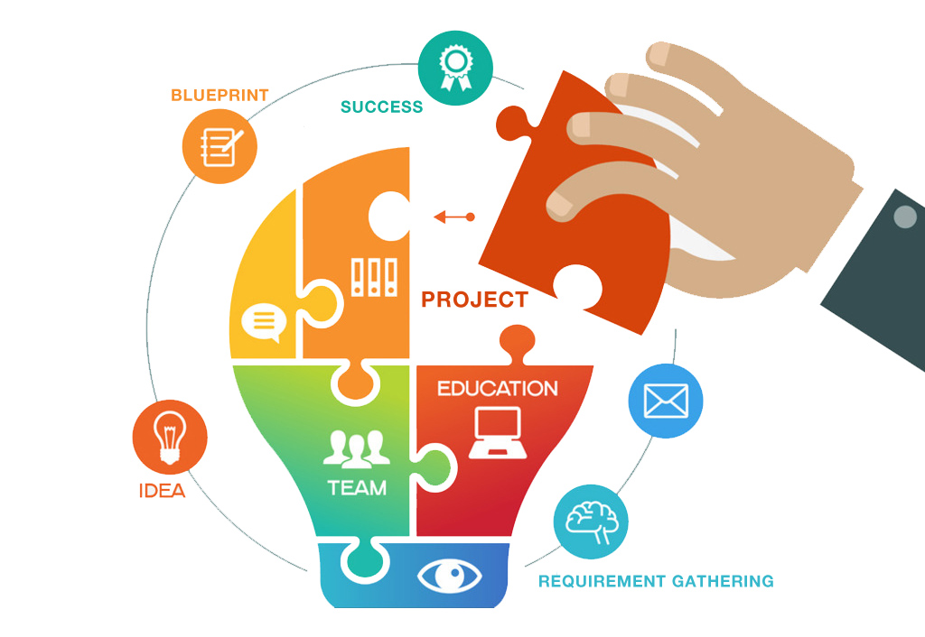

## 3.2 Project requirement analysis:

Requirement analysis is the process of determining user expectations for a new or modified system. These features, called requirements, must be quantifiable, relevant and detailed. Requirements are a description of how a system should behave or a description of system properties or attributes. It can alternatively be a statement of 'what' an application is expected to do.

Based on gathered information, it leads to demand of simple interactive media platform of farm practices to create better understanding. After the requirements have been analyzed, the project perspectives of the interactive media have been decided.

# 4.0 Project perspective:

## 4.1 Preamble:

Technologies developed within laboratories and research Filed, must reach farmers at earliest. Multimedia is one of the effective media for dissemination of the information to farmers among all other ways of communication. For example photographs of symptoms of diseases, insect pest damage and of insects can be made available using multimedia for their effective monitoring and management.

The digital green system disseminates targeted agricultural information to small and marginal farmers through digital video and animation Clip. Farmers are motivated and trained by these recorded experience. To create videos and animation clips for good agriculture practices and adoption of new technology to be used during extension and awareness program.

## 4.2 Objectives:

* To disseminate Cotton Crop information to farming community using multimedia.

## 4.3 Scope:

* This project will be used by only the regional farmer to gain and implement the knowledge better farm practices.

## 4.4 Limitation of the proposed system:

* The system provides reliable information for only one crop’s package of practices.

# 4.5 About the existing system and newly proposed system:

|  |  |  |
| --- | --- | --- |
| Traditional Approach | Current Approach | Multimedia Approach |
| Media used: | Media used: | Media used: |
| Print based | Print based, on farm demonstration | Electronic media, CD, Website |
| Resources utilization: | Resources utilization: | Resources utilization: |
| Require few resources | Require more resources | Require fewer resources |
| Available information: | Available information: | Available information: |
| Improper format of information but easy to access | Very less information available in proper format and difficult to access | Maximum information has been covered in proper format and easy to access |
| Fewer farmers have been approached. | Few farmers have been approached. | Maximum numbers of farmers have been approached efficiently. |

# 4.6 Key Features:

* + - Easy to understand
* Virtual farm practices demonstration techniques
* Easy to operate
* Language specific and culture or region specific content
* Conveyed information should be authenticated by research institutions

# 4.7 Internal environment:

Internal environmental factors are events that occur within an organization. Generally speaking, internal environmental factors are easier to control than external environmental factors. Some examples of internal environmental factors are as follows:

* 3D modeling
* Sound interface and structure designing

# 4.8 External environment:

External environmental factors are events that take place outside of the organization and are harder to predict and control. External environmental factors can be more dangerous for an organization given the fact they are unpredictable, hard to prepare for, and often bewildering. Some examples of external environmental factors are noted below:

* Deployment of media player for execution

# 5.0 Feasibility Study

## 5.1 Technical feasibility

### 5.1.1 Hardware interface:

* The system must interface with the standard output device, keyboard and mouse to interact with this software.
* For execution of the proposed system one has to have CD drive or DVD drive.

### 5.2.2 Software interface:

* **Back End:** Action Script 3.0 (Adobe Flash)
* **Front End:**
  + Adobe Photoshop CC 2015
  + Adobe Flash CC 2015
  + Adobe After Effects CC 2015
  + Adobe Audition CC 2015
  + Adobe Premiere Pro CC 2015
  + Adobe Media Encoder CC 2015
  + 3Ds Max 2015

### 5.2.3 Network interface:

* There are no internet connectivity require for deployment of the system.

### 5.2.4 Memory constrain:

* No specific constraints on memory.

### 5.2.5 Operations:

* The system have been deployed to compact disk (CD), so farmer can better understood the farm practices which leads to better farm produces.

### 5.2.6 User characteristics:

* The Product has better navigation among the contents, so one can easily access the contents.
* The product does not expect the user to possess any technical background. Any person who knows to use the mouse and the keyboard and gave basic knowledge of computer can successfully use this product.

## 5.2 Economics feasibility:

* The software which is used to develop the projects is licensed software but with student ID, it can be used freely for three years except Adobe Flash CC 2015.
* The hardware needed to deploy systems is CD which can cost minimal amount i.e. 20 or 25 RS.
* This system doesn’t require network connectivity hence doesn’t cost any.

## 5.3 Operational or behavioural feasibility:

* The newly proposed system can be operated easily as it doesn’t require any special skills.

# The system is easy to understand and can be deployed easily in any form like CDs, DVDs or any hardware memory device.

# 6.0 Project Planning:

## 6.1 Planning approach for multimedia project:

Any significant multimedia project involves a core team that includes: producer, writer, and director, who work with other personnel, such as, programmer, photographer, videographer, and voiceover artists.

Multimedia project planning is a complex problem. Any significant multimedia project involves a core team that includes: producer, writer, and director, who work with other personnel, such as, programmer, photographer, videographer, and voiceover artists. Close coordination between these team members is essential. The Multimedia Design and Planning Pyramid (MUDPY) is a five-level model (Fig. 1) in which the top three levels comprise the project planning process. The planning process should begin by articulating a clear Concept statement, and then expand it into Goals and Requirements.

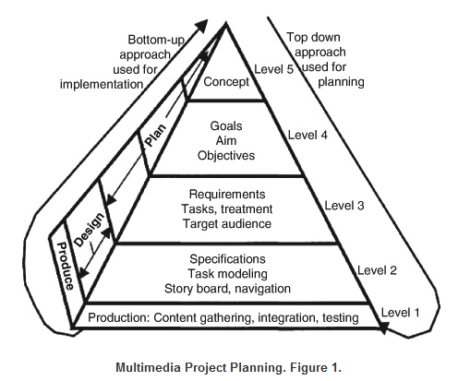

# 

# 7.0 Project design:

Designing and building multimedia project the following skills required:

* Knowledge about multimedia basic concepts
* Computer designing skills
* Shooting skills
* Knowledge of advanced 3D modeling and animation
* Ability to conceptualize logical pathways

The multimedia project designing consist of two major parts:

1. Structure Designing
2. User Interface Designing

## 7.1 Structure Designing:

The manner in which project material is organized has just as great an impact on the viewer as the content itself. Structure designing mainly done by:

1. Navigation maps
2. Architectural drawing
3. Hotspots
4. Hyperlinks
5. Icon and buttons

### 6.1.1. Navigation maps:

Maps designing have been done early in the planning phase and help to organize the content and messages. Maps provide a hierarchical table of contents and a chart of the logical flow of the interactive interface.Essentially, they are non-linear. In case of project, the navigation map is non linear as Users navigate freely through the content, unbound by predetermined routes and it is as follow:

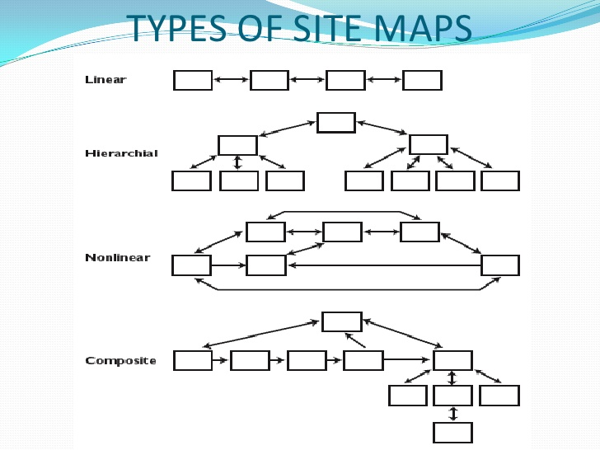

### 7.1.2 Architectural drawing

Architecture drawing mainly contents the storyboard of a system. Storyboards are linked to navigation maps during the design process, and help to visualize the information architecture. The surface structure of storyboard represents the structures actually realized by a user while navigating the depth structure while the depth structure of storyboard represents the complete navigation map and describes all the links between all the components of the project.

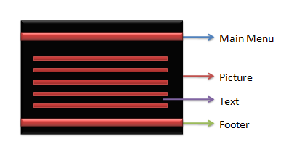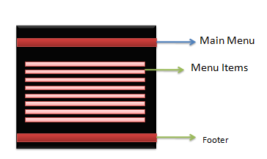

**Home Page Sub Menu**

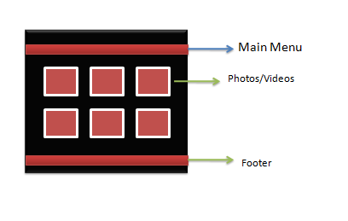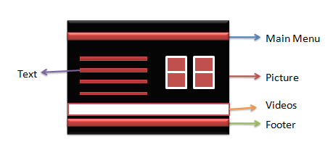

**Album MenuContent Page**

### 7.1.3 Hotspots:

This adds interactivity to a multimedia interactive project. Categories of hotspots are text, graphic, icon etc. The simplest hot spots on the Web are the text anchors that link a document to others documents. In proposed system, usually buttons and graphic are used as a hotspot.

### 7.1.4 Hyperlinks:

A hotspot that connects a viewer to another part of the same document or different document or another web site. The proposed system has no or very fewer hyperlinks.

### 7.1.5 Icon and buttons:

Icons are fundamental graphic objects symbolic of an activity or concept.A graphic image that is a hotspot is called a button.Plug-ins such as Flash, Shockwave, or JavaScriptenables users to create plain or animated buttons. Small JPEG or GIF images that are themselves anchor links can also serve as buttons on the web.

## 7.2 User Interface Designing:

### 7.2.1 Graphical User Interface Designing:

It is a blend of graphic elements and navigation system. It can contain plenty of navigational power, which provides access to content and tasks for users at all levels.The interface should be simple and user-friendly.The GUIs of Macintosh and Windows are successful due to their simplicity, consistency, and ease of use.GUIs offer built-in help systems, and provide standard patterns of activity that produce the standard expected results. While developing theGUI of the system consider that UI is neatly executed contrasts, gradients and shadows are proper and UI should be eye-grabbers. One should avoid the clashes of color, busy screens, requiring more than two button clicks to quit, too many numbers and words, too many substantive elements presented too quickly.

### 7.2.2 Audio Interface:

A multimedia user interface can include sound elements.Sounds can be background music, special effects for button clicks, voice-overs, effects synced to animation.Always provide a toggle switch to disable sound.

# 8.0 How system works?

# 8.1 System navigation:

# 8.2 User manual:

# 9.0 Conclusion:

In the end, to minimize the resource utilization and provide a better approach to extension in agriculture sector, harness of multimedia skills and techniques are required. The multimedia techniques develop virtual farm demonstration that is low cost technology as well as can be accessed easily. Therefore, the agriculture extension approach can be maximized to region or state farmer. The farmer can easily understand as it is language specific and culture specific interactive media that leads to good farm practices.

# 10.0 Bibliography:

* http://www.slideshare.net/lunkyo/multimedia-planning-3536990
* http://link.springer.com/referenceworkentry/10.1007%2F978-0-387-78414-4_146
* http://www.ascd.org/publications/books/102112/chapters/What_Is_ProjectBased_Multimedia_Learning%C2%A2.aspx
* Encyclopedia of multimedia by Springer (1st Edition)

************************